2022 PTA
Summer Reading Program
The PTA Summer Reading Program is starting June 18th!
Here’s what you do over the summer:
- Read, read and read some more!
- Use the summer reading calendars to record the
minutes you read each day.
- Make sure your FULL name (first and last name) is on the reading calendar!
Here’s what you do in September:
- When school starts, bring your reading calendar to school
by September 16th.
- Reading calendars can be turned into your teacher or to the PTA Summer Reading Program box in the atrium
- For students who reach their Golden Effort Goal, prizes will be awarded at the end of September.
- For students who reach their Royal Reader Goal, you will earn some small prizes and a free book from the PTA at the end of September!
Royal Reading Goals for each grade level: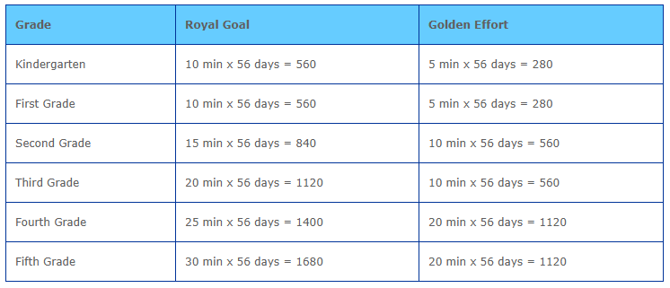
Please email Mrs. Gerber or Mrs. Watrous if you have any questions.
gerbern@issaquah.wednet.edu watrouss@issaquah.wednet.edu

